5. SECOND LAW OF THERMODYNAMICS
THERMAL ENERGY RESERVOIRS:
HEAT SOURCE: It’s a thermal energy reservoir which supplies heat at constant temperature. E.g. Hot Gas in IC engine, Fission in nuclear reactors, Hot gases in boiler furnace. | HEAT SINK: It’s a thermal energy reservoir which absorbs heat at constant temperature. E.g. Atmosphere, River Water, Ocean.
STATEMENT OF SECOND LAW:
KELVIN-PLANK’S STATEMENT: It’s impossible to construct a device which is operating on a cycle and producing work continuously and exchanging heat with single reservoir. | CLAUSIUS STATEMENT: It’s impossible to construct a device which operates on a cycle and transferring heat from low temperature body to high temperature body without any external work input.
PERPETUAL MOTION MACHINE OF SECOND KIND (PMM-II): It’s impossible to have 100% efficiency of engine. And It violates the second law of thermodynamics.
HEAT ENGINE:
It works on cycle and takes heat from higher energy medium and converts in to work and transfers remaining heat to lower energy medium. E.g. IC Engine, Steam Power Plant, Gas Turbine Power Plant.
FIRST LAW OF THERMODYNAMICS TO HEAT ENGINE: It’s valid for reversible and irreversible process.
For Cycle, $Q_{net}=W_{net} ⇒W_{net}=Q_{1}-Q_{2}$  $$η=\frac{O/P}{I/P}=\frac{W_{net}}{Q_{1}}=1-\frac{Q_{2}}{Q_{1}}$$ | $Q_{1}$= Heat Supplied to Engine,  $Q_{2}$= Heat Rejected from Engine,  $W_{net}$= Work Done by Engine, | $$T_{1}$$  $${HE}_{1}$$ $$→W_{1}$$  $$T_{2}$$
CARNOT CYCLE:
- It’s reversible cycle.  - It’s work producing cycle (Clockwise Dir.)  Processes:  1-2: Rev. Isothermal Heat Supply Expansion  2-3: Rev. Adiabatic Expansion  3-4: Rev. Isothermal Heat Rejection Compression  4-1: Rev. Adiabatic Compression. | 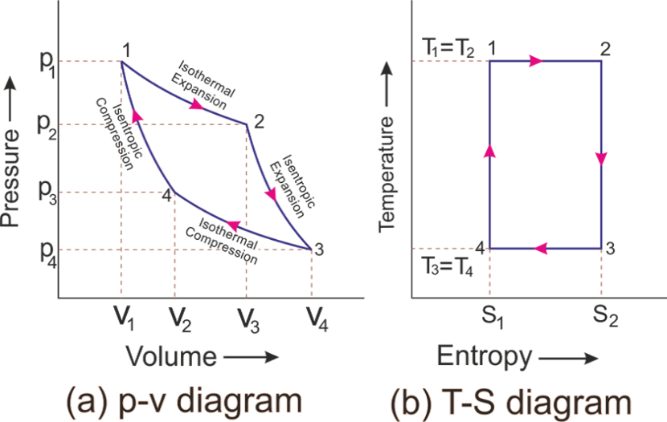 | 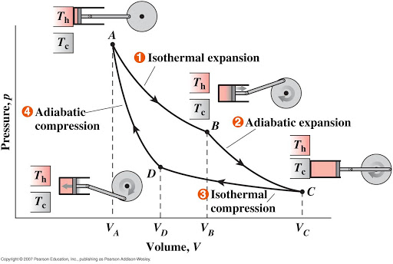
Here,  $$T_{1}=T_{2}=T_{H}$$ $$T_{3}=T_{4}=T_{L}$$  $$Q_{1}=Q_{S}$$ $$Q_{2}=Q_{R}$$  Process 1-2: $Q_{1}=P_{1}V_{1} ln \left({V_{2}}/{V_{1}}\right)=mRT_{H}ln \left({V_{2}}/{V_{1}}\right)$  Process 3-4: $Q_{2}=P_{3}V_{3} ln \left({V_{3}}/{V_{4}}\right)=mRT_{L}ln \left({V_{3}}/{V_{4}}\right)$ |  | From process 2-3 & 4-1:  $$\frac{T_{H}}{T_{L}}={\left(\frac{V_{3}}{V_{2}}\right)}^{γ-1}={\left(\frac{V_{4}}{V_{1}}\right)}^{γ-1}$$  $$η=\frac{W_{net}}{Q_{1}}=1-\frac{Q_{2}}{Q_{1}}=1-\frac{T_{2}}{T_{1}}(Vaild for Rev. only)$$
IMPORTANT POINTS:
- Two Rev. isothermal and Two Rev. adiabatic process.  - Ideal Cycle for H.E. and gives $η_{max}$.  - Not Practical cycle since Rev. isothermal and Rev. Adiabatic are difficult to achieve in practice.  - $η_{Carnot}$ depends only on temperature Limits.  - $η_{Carnot}$ doesn’t depend on working fluid (E.g. gas or Vapour or etc…) | - For exam problems,  $$W_{net}↑⇔η↑$$ $$Q_{1}↓⇔η↑$$  $$W_{max}⇔η_{max}=η_{Carnot}$$ $$Q_{1 min}⇔η_{max}=η_{Carnot}$$  - For Cyclic Rev. Process, ${Q_{1}}/{T_{1}}={Q_{2}}/{T_{2}}$  - Carnot cycle is used to compare practical H.E. Efficiency.  Only Temp. Given or Rev. H.E. or Carnot Cycle Simple H.E. or T1, T2 & Q1, Q2 given or Irreversible or Practical H.E.  $$η=1-\left({T_{2}}/{T_{1}}\right)$$ $$η=1-\left({Q_{2}}/{Q_{1}}\right)$$

TWO REVERSIBLE HEAT ENGINES IN SERIES:
Efficiencies are same:  $$η_{1}=η_{2}$$  $$⇒T_{2}=\sqrt{T_{1}T_{3}}$$  $$\left[∵η equation\right]$$ | Work Outputs are Same,  $$W_{1}=W_{2}$$  $$Q_{1}-Q_{2}=Q_{1}-Q_{2}$$  $$T_{2}={T_{1}+T_{3}}/2$$  $$\left[∵{Q_{1}}/{T_{1}}={Q_{2}}/{T_{2}}={Q_{3}}/{T_{3}}=c\right]$$ | Overall Efficiency in terms of Temp.,$$η_{Overall}=1-\left({T_{3}}/{T_{1}}\right)$$  $$η_{Overall}=η_{1}+η_{2}-η_{1}η_{2}$$  $$\left[∵η equation\right]$$ | $$T_{1}$$  $${HE}_{1}$$ $$→W_{1}$$  $$T_{2}$$  $${HE}_{2}$$ $$→W_{2}$$  $$T_{3}$$
REFRIGERATOR:
It works on cycle and absorbs heat from lower energy medium and rejects heat to higher energy medium by consuming work. E.g. Domestic Refrigerator, Air Conditioner, Water Cooler, Ice Plant.
$$Coefficient of Performance, COP=\frac{Desired Effect}{Energy Input}$$
For Cycle, $Q_{net}=W_{net} ⇒W_{net}=Q_{1}-Q_{2}$  $${COP}_{R}=\frac{Cooling Effect}{Energy Input}=\frac{Q_{2}}{W_{net}}=\frac{Q_{2}}{Q_{1}-Q_{2}}$$  It’s Valid for Rev.& Irreversible Cycle.  If Refrigerator Door is Open in room, Room temperature increase. | $Q_{1}$= Heat Rejected to Refrigerator,  $Q_{2}$= Heat Absorbed by Refrigerator,  $W_{net}$= Work Supplied to Refrigerator,
REVERSIBLE CARNOT CYCLE:
- It’s reversible cycle.  - It is work consuming cycle (Anti-Clockwise Dir.)  - It gives maximum ${COP}_{R}$.  Processes:  1-2: Rev. Adiabatic Compression (Compressor Work)  2-3: Rev. Isothermal Heat Rejection. (Heat Exchanger)  3-4: Rev. Adiabatic Expansion. (Throttling)  4-1: Rev. Isothermal Heat absorption. (Refrigerating effect). | 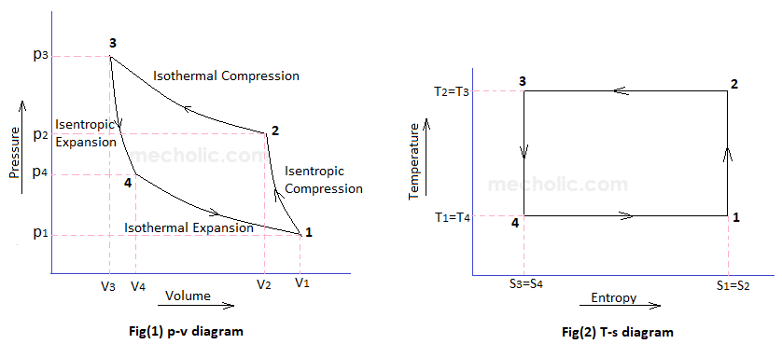
Here,  $$T_{1}=T_{4}=T_{L}$$ $$T_{2}=T_{3}=T_{H}$$  $$Q_{1}=Q_{R}$$ $$Q_{2}=Q_{A}$$  Process 2-3: $Q_{1}=P_{2}V_{2} ln \left({V_{3}}/{V_{2}}\right)=mRT_{H}ln \left({V_{2}}/{V_{3}}\right)$  Process 4-1: $Q_{2}=P_{3}V_{3} ln \left({V_{1}}/{V_{4}}\right)=mRT_{L}ln \left({V_{4}}/{V_{1}}\right)$ |  | From process 1-2 & 3-4:  $$\frac{T_{H}}{T_{L}}={\left(\frac{V_{4}}{V_{3}}\right)}^{γ-1}={\left(\frac{V_{1}}{V_{2}}\right)}^{γ-1}$$  $$∴{COP}_{R}=\frac{Q_{2}}{Q_{1}-Q_{2}}=\frac{T_{L}}{T_{H}-T_{L}}(Vaild for Rev. only)$$
IMPORTANT POINTS:
- Two Rev. isothermal and Two Rev. adiabatic process.  - Ideal Cycle for Refrigerator and gives ${COP}_{R max}$.  - Not Practical cycle since Rev. isothermal and Rev. Adiabatic are difficult to achieve in practice. | - ${COP}_{R}$ depends only on temperature Limits.  - ${COP}_{R}$ doesn’t depend on working fluid (E.g. gas or Vapour or etc…)  - For exam problems,  $$Q_{2}↑⇔COP↑$$ $$W_{net}↓⇔COP↑$$  $$Q_{2 max}⇔$$ $${COP}_{max}={COP}_{Rev. R}$$ $$W_{net min}⇔$$ $${COP}_{max}={COP}_{Rev. R}$$
TWO REVERSIBLE REFRIGERATORS ENGINES IN SERIES:
COPs are same:  $${COP}_{1}={COP}_{2}$$  $$⇒T_{2}=\sqrt{T_{1}T_{3}}$$  $$\left[∵COP equation\right]$$ | Work Inputs are Same,  $$W_{1}=W_{2}$$  $$Q_{1}-Q_{2}=Q_{2}-Q_{3}$$  $$T_{2}={T_{1}+T_{3}}/2$$  $$\left[∵{Q_{1}}/{T_{1}}={Q_{2}}/{T_{2}}={Q_{3}}/{T_{3}}=c\right]$$ | Overall COP,  $${COP}_{Overall}={T_{3}}/{\left(T_{1}-T_{3}\right)}$$  $${COP}_{Overall}=\frac{{COP}_{1}{COP}_{2}}{1+{COP}_{1}+{COP}_{2}}$$  $$\left[∵COP equation\right]$$ | $$T_{1}$$  $$W_{1}→$$ $${REF}_{1}$$  $$T_{2}$$  $$W_{2}→$$ $${REF}_{2}$$  $$T_{3}$$
HEAT PUMP (HEAT TRANSFORMER): It’s same as refrigerator only concern medium is higher temperature whereas in refrigerator concern medium is lower temperature medium.
For Cycle, $Q_{net}=W_{net} ⇒W_{net}=Q_{1}-Q_{2}$  $${COP}_{HP}=\frac{Heating Effect}{Energy Input}=\frac{Q_{1}}{W_{net}}=\frac{Q_{1}}{Q_{1}-Q_{2}}$$  It’s Valid for Rev.& Irreversible Cycle.  - Derivations are same as refregerator only COP equation changes. | $Q_{1}$= Heat Rejected to Cabin,  $Q_{2}$= Heat Absorbed by Atmosphere,  $W_{net}$= Work Supplied to Heat Pump, | $$T_{1}$$  $$W_{1}→$$ $${HP}_{1}$$  $$T_{2}$$
$$∴{COP}_{HP}=\frac{Q_{1}}{Q_{1}-Q_{2}}=\frac{T_{H}}{T_{H}-T_{L}}=\frac{T_{1}}{T_{1}-T_{2}}$$
It’s Valid for Reversible Cycle only.
IMPORTANT POINTS:
- Two Rev. isothermal and Two Rev. adiabatic process.  - Ideal Cycle for Refrigerator and gives ${COP}_{HP max}$.  - Not Practical cycle since Rev. isothermal and Rev. Adiabatic are difficult to achieve in practice. | - ${COP}_{HP}$ depends only on temperature Limits.  - ${COP}_{HP}$ doesn’t depend on working fluid (E.g. gas or Vapour or etc…)  - For exam problems,  $$Q_{1}↑⇔COP↑$$ $$W_{net}↓⇔COP↑$$  $$Q_{1 max}⇔$$ $${COP}_{max}={COP}_{Rev. HP}$$ $$W_{net min}⇔$$ $${COP}_{max}={COP}_{Rev. HP}$$
RELATION BETWEEN REFRIGERATOR & HEAT PUMP:
From ${COP}_{HP}, {COP}_{R}$ & Energy Balance, | $${COP}_{HP}={COP}_{R}+1$$
RELATION BETWEEN HEAT ENGINE & HEAT PUMP:
From ${COP}_{HP}, η_{HE}$ Equations, | $$η_{HE}=1/{{COP}_{HP}}$$
$$Always, η<1$$ | $$Always,COP≥1$$
ELECTRICAL HEATING COIL OR ELECTRIC RESISTANCE HEATER:
$${COP}_{Coil}=\frac{Heating Effect}{Energy Input}=\frac{Q_{1}}{W_{net}}=\frac{W_{Ele.}}{W_{Ele.}}=1({∵Q}_{1}=W_{net}=W_{Ele.})$$
HEAT PUMP | ELECTRIC HEATER
It’s better than electric heater because energy consumption is less ($W_{net}=Q_{1}-Q_{2}$) | Energy consumption is high ($Q_{1}=W_{Ele.}$)in comparison so it’s not better to use.

SPECIAL CASE OF REFRIGERATOR:
REFRIGERATED SPACE WITH VENTILATION: Room is opened to atmosphere. Hence, it’s constant Pressure process. | $$Q_{2}=mC_{P}dT$$
REFRIGERATED SPACE WITH PERFECTLY SEALED & INSULATED: Room is Insulated & Closed System (Room with no opening). Hence, it’s constant Volume process. | $$Q_{2}=mC_{V}dT$$
CALCULATION OF POWER BILL FOR REFRIGERATION MACHINE:
$Power Bill = \dot{W}\left(Consumption in KWh\right)*{Cost}_{Ele}(Unit price in{Rs}/{KWh})$ | $$1 KWh=1 Unit=3600 KJ$$
COMBINED HEAT ENGINE & REFRIGERATORS:
$$W_{HE}=Q_{1}-Q_{2}$$  $$W_{R}=Q_{4}-Q_{3}$$ | $$W_{HE}=W_{R}=W$$ | $${COP}_{R}=\frac{Q_{3}}{W}=\frac{Q_{3}}{Q_{4}-Q_{3}}$$ | $$η=\frac{W}{Q_{1}}=1-\frac{Q_{2}}{Q_{1}}$$ | $$T_{1}$$ $$Q_{1}$$ $$T_{4}$$ $$Q_{4}$$  $${HE}_{1}$$ $$→W→$$ $${REF}_{1}$$  $$T_{2}$$ $$Q_{2}$$ $$T_{3}$$ $$Q_{3}$$
$$Net Work Output of Combined System, W_{Net}=W_{HE}-W_{R}$$
COMBINED HEAT ENGINE & HEAT PUMP:
$$W_{HE}=Q_{1}-Q_{2}$$  $$W_{HP}=Q_{4}-Q_{3}$$ | $$W_{HE}=W_{HP}=W$$ | $${COP}_{HP}=\frac{Q_{4}}{W}=\frac{Q_{4}}{Q_{4}-Q_{3}}$$ | $$η=\frac{W}{Q_{1}}=1-\frac{Q_{2}}{Q_{1}}$$ | $$T_{1}$$ $$Q_{1}$$ $$T_{4}$$ $$Q_{4}$$  $${HE}_{1}$$ $$→W→$$ $${REF}_{1}$$  $$T_{2}$$ $$Q_{2}$$ $$T_{3}$$ $$Q_{3}$$
$$Net Work Output of Combined System, W_{Net}=W_{HE}-W_{R}$$

CLAUSIUS INEQUALITY: It’s Valid for H.E., Refrigerator & H.P. | $$\oint{dS}≤0, Where dS=\frac{Q}{T}$$ | $Q$ = Heat Transfer (in J),  $T$ = Absolute Temp. (in K),
If $\oint{dS}=0$, Reversible Cycle.  $$E.g. {Q_{1}}/{T_{1}}={Q_{2}}/{T_{2}}$$ | If $\oint{dS}<0$, Irreversible Cycle.  $$E.g. η_{irr}<η_{Carnot}$$ | If $\oint{dS}>0$, Impossible Cycle.
HEAT ENGINES WITH MULTIPLE RESERVOIRS: $η_{HE}=1-\left({\sum{Q_{iS}}}/{\sum{Q_{iR}}}\right)$
PERPETUAL MOTION MACHINE OF THIRD KIND (PMM-III): The continual motion of a movable device in absence of friction.

